The following instructions are designed to run these tests in Firefox version 32.0.3

Ensure Ruby is not currently installed (go to command prompt and type ‘Ruby –v’)

If Ruby version displays please uninstall current version before following these instructions further

Go to <http://rubyinstaller.org/downloads/>

Download Ruby 1.9.3-p545

Begin installation

Accept license agreement

Select all checkboxes (see image) and go with default location

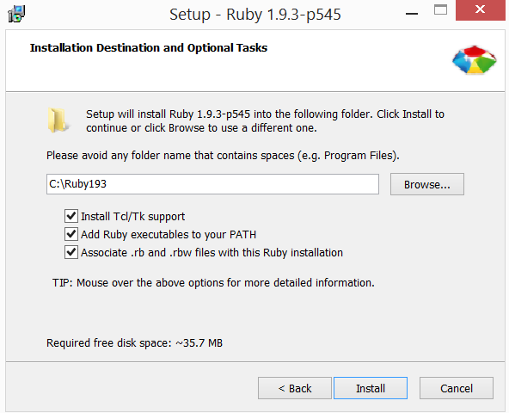

Open command prompt

Change directory to project directory (example: ‘cd c:\github\SOLID\OCP\Cukes’)

type ‘ruby –v’ at command prompt

You should see the following message:

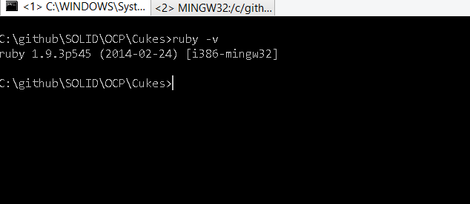

Type ‘gem install bundler –v 1.7.3’ to install bundler

Type ‘bundle install’ in directory with Gemfile (example: c:\github\SOLID\OCP\Cukes\)

Type ‘bundle exec cucumber –tags @missionControl’